- Real-World Devices That Use SMPS (Switched Mode Power Supply) and UPS (Uninterruptible Power Supply)

- Devices that use SMPS (Switched Mode Power Supply)

- Desktop Computer (CPU) – Uses an SMPS to efficiently convert AC mains power into multiple regulated DC voltages required by internal components.
- Laptop Charger – Uses an SMPS because it provides efficient, lightweight, and stable DC output for charging the laptop battery.
- LED Television – Uses an SMPS to supply different DC voltages with high efficiency while generating less heat.

- Devices that use UPS (Uninterruptible Power Supply)

- Desktop Computer in a Computer Lab – Connected to a UPS to prevent data loss and allow safe shutdown during power outages.
- Wi-Fi Router/Networking Equipment – Uses a UPS to keep the internet connection active during short power cuts.

- Diagram of the Main Internal Components of a Typical SMPS (Desktop PC)

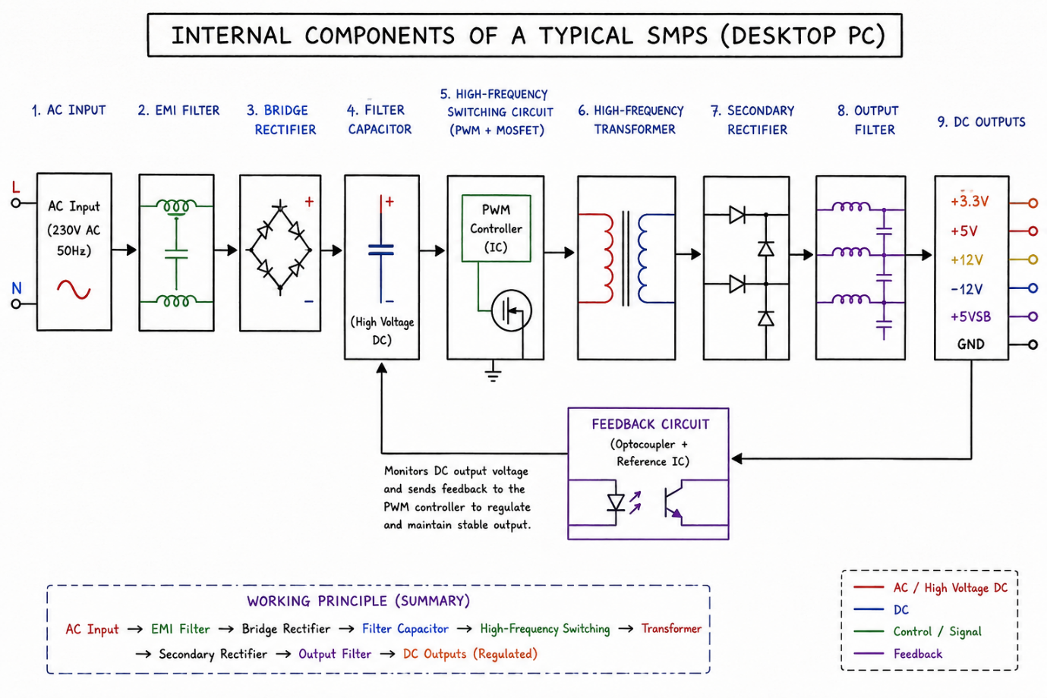

- Power Connectors Used in a Desktop PC

- ATX 24-pin Motherboard Connector

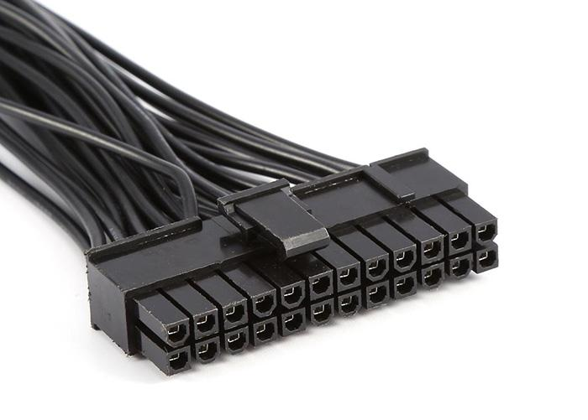

Name: ATX 24-pin Motherboard Connector
Devices it Powers: Powers the motherboard and supplies power to the CPU, RAM, and other onboard components.
Safety Tip: Turn off the power supply and unplug the PC before connecting or disconnecting this connector.

- SATA Power Connector

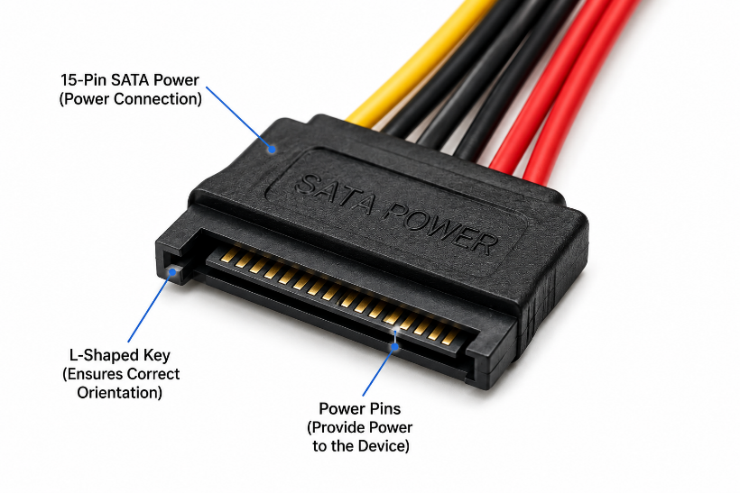

Name: SATA Power Connector
Devices it Powers: Powers SATA hard disk drives (HDDs), solid-state drives (SSDs), DVD/Blu-ray drives, and some RGB or fan controllers.
Safety Tip: Align the L-shaped connector correctly and never force it into the device.

- Molex Connector (4-pin)

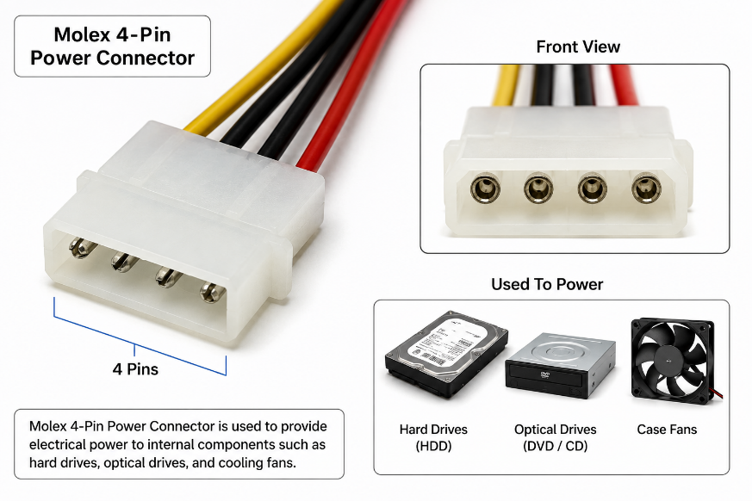

Name: Molex 4-pin Power Connector
Devices it Powers: Powers older IDE hard drives, optical drives, cooling fans, and other legacy peripherals.
Safety Tip: Hold the plastic connector while unplugging it; never pull directly on the wires.

- PCIe 6/8-pin Power Connector

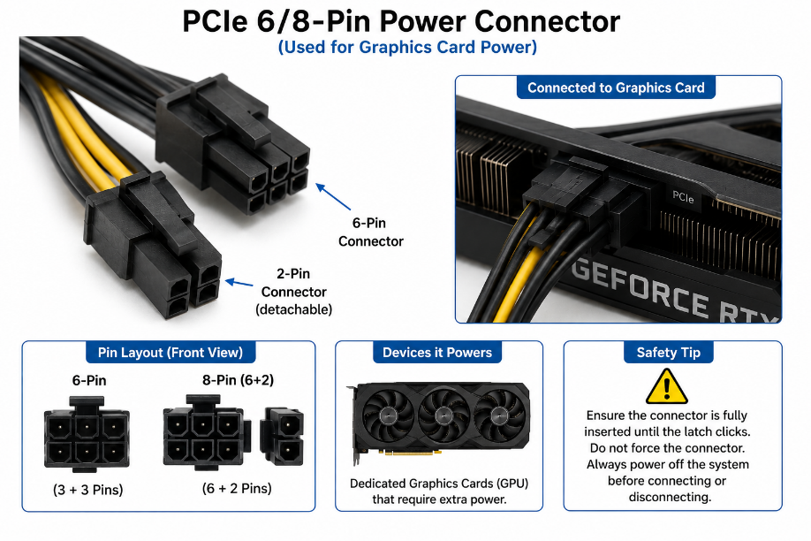

Name: PCIe 6/8-pin Power Connector
Devices it Powers: Supplies additional power to dedicated graphics cards (GPUs) and other high-power PCIe devices.
Safety Tip: Make sure the connector is fully inserted and the locking clip clicks into place before turning on the computer.

- Connecting the SMPS to a New Gaming PC

Step 1: Turn Off the Power Supply
- Ensure the SMPS is switched OFF and unplugged from the wall socket.
Step 2: Connect the Motherboard
- Cable/Connector Used: 24-pin ATX Motherboard Power Connector
- Connect the 24-pin ATX cable from the SMPS to the motherboard until the locking clip clicks into place.
Step 3: Connect the CPU
- Cable/Connector Used: 4+4-pin (8-pin) CPU/EPS Power Connector
- Connect the CPU power cable near the processor socket on the motherboard.
Step 4: Connect the Graphics Card (GPU)
- Cable/Connector Used: PCIe 6-pin or 8-pin (6+2) Power Connector
- Plug the PCIe power connector into the graphics card if it requires external power.
Step 5: Connect the Storage Devices
- Cable/Connector Used: SATA Power Connector
- Connect the SATA power cable from the SMPS to the SSD, HDD, or DVD drive.
Step 6: Connect Other Components (if required)
- Cable/Connector Used: Molex 4-pin Connector
- Connect Molex power to older case fans, optical drives, or other legacy devices.
Step 7: Final Check
- Verify that all connectors are fully inserted and the locking clips are secured.
Step 8: Power On the PC
- Connect the AC power cable to the SMPS, switch it ON, and start the computer.

- Connectors Used Summary

Component | Connector Used
Motherboard | 24-pin ATX Power Connector
CPU | 4+4-pin (8-pin) CPU/EPS Power Connector
Graphics Card (GPU) | PCIe 6-pin / 8-pin (6+2) Power Connector
SSD/HDD/DVD Drive | SATA Power Connector

